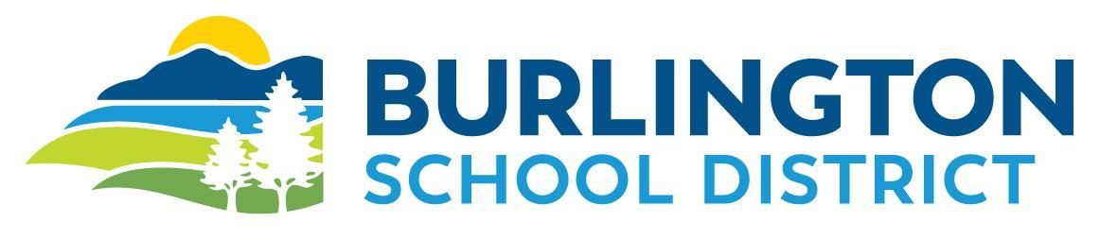

August 16, 2023

Dear Parents & Guardians:

This letter is intended for all families with a student who may be riding a GMT bus to or from school during the upcoming school year. BSD continues to work cooperatively with GMT to provide bus transportation options for your student(s) to travel to and from school.

Grades K-5 students who live more than ¾ of a mile away from their assigned school and grades 6-12 students who live more than 1 mile away from their assigned schools are eligible for fare-free boardings on GMT buses between 7 AM & 7 PM on school days when traveling to/from school. Students who are eligible for fare-free boarding will be issued a school I.D. with a GMT logo by January 2, 2024. Effective January 2, 2024 all students who wish to ride a GMT bus must present a school issued ID when boarding the bus or pay the $1.00 cash fare to ride the bus.

Students who are not eligible for fare-free boarding must pay the $1.00 cash fare to ride aboard GMT buses.
To ensure a safe and comfortable ride for all GMT passengers the GMT Passenger Code of Conduct is expected to be followed by all passengers on all GMT buses. The complete Code of Conduct can be found at: http://ridegmt.com/passenger-code-of-conduct/

Neighborhood Specials route schedules can be found at: https://ridegmt.com/gmt-schedules/

If you have any questions about the above information, please contact our office at 802-864-8453 or GMT directly at 802-540-2468 or info@ridegmt.com.

Sincerely,

Kyle Toof
BSD Transportation Manager
864-8453

